**2018 Vancouver Elementary School**

**Track and Field Championships**

**Gr. 3-7**

Hosted By: University of British Columbia Track and Field

Sanctioned By: BC Athletics

Meet Director/Contact: Reid Graham - [UBCMeetDirector@gmail.com](mailto:UBCMeetDirector@gmail.com) - 778-828-3484

Competition date**: April 25th, 2018**

Venue**:** Rashpal Dhillon Track and Field Oval, UBC Campus (Corner of Wesbrook/16th Ave)

**Events:** Gr. 3&4&5 - 60m, 100m, 600m, 1000m, LJ, HJ, SP, 4x100m

**Events:** Gr. 6&7 - 100m, 200m, 300m, 800m, 1200m, LJ, HJ, SP, 4x100m

**Events:** University – 5/10km Racewalk. At 3pm. ($8US)

**Entries:** Entries are only accepted online. Payment can be made on-line or by cheque. Follow the link: <https://www.directathletics.com/meets/track/51567.html>

**Schedule, Results, and Meet Package:** For the most up-to-date version of the schedule, results, and meet information (this document), please follow the link and pick from the list as seen below: <https://github.com/UBCTrackMeet/ElementarySchedule>

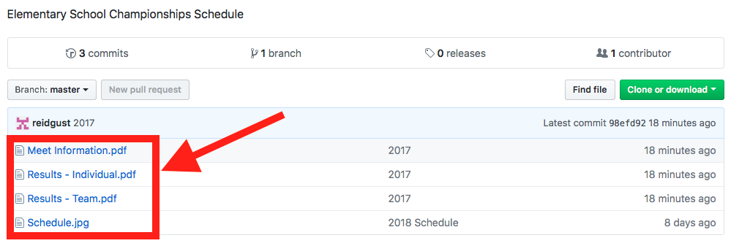

**Entry fee**: US$6 per event, US$7 per relay team. Being part of the NAIA we have to use an American registration system. If paying by cheque we will send an invoice with the exchange rate on the day the invoice is issued.

**Entry deadline**: **April 19, 2018 at 5:00pm**. By 7:00pm we will send out the full list of athletes and all the events in which they are entered. Please notify us of any discrepencies by 5:00pm April 20th.

**Late fee**: CAN$15.00 per event, CAN$20 per relay team.

Late entries will be accepted from April 20-April 24th at 5:00pm via email to Reid Graham - [UBCMeetDirector@gmail.com](mailto:UBCMeetDirector@gmail.com)

Late fee for day-of-competition entry is ***$25 per event and $30 per relay***. Meet organizers have the right to refuse entry, depending on availability. **Entry fees will not be refunded for any reason. (Scratch, injury etc).**

**Check-in Procedure:** All athletes must report to their event when check-in is announced. Athletes not checked will be scratched.

**Warm-up:** Athletes must warm-up outside of the track facility (grass areas outside of the fence).

**General Meet Information:**

1. All athletes must compete in their school/club singlet or t-shirt wearing their race number on the **front**.

2. We encourage BCA School Membership: [www.bcathletics.org/TrackAndField/Membership](http://www.bcathletics.org/TrackAndField/Membership)

3. All track sections are Timed Finals.

4. Throwers and Long Jumpers will each be given three attempts.

5. Starting height for High Jump will be .75m for Gr. 3, .95m for Gr. 4-5 and 1.05m for Gr. 6-7.

6. **Entry in the long jump will be limited to 6 athletes** per school per division (age & gender group).

**Awards:**

Team Champion trophies will be awarded to the top male and female school team for each grade. Medals will be awarded to the winner and ribbons will be awarded to finishers 2nd-8th in each individual event.

**Scoring:**

Team scores will be calculated based on athlete point totals, calculated as follows:

1st – 10 pts, 2nd – 8pts, 3rd – 6pts, 4th – 5pts, 5th – 4pts, 6th – 3pts, 7th – 2pts, 8th – 1p, Relays 2X pts

**Admission**: Free. Spectators are not allowed on the track and must stay behind roped off areas.

**Footwear:** Max spike length of 7mm will be enforced. Athletes not complying with this specification will not be allowed to compete.

**Race Numbers:** The race numbers will be customized to each athlete as shown in the demo below. If the athlete is **competing in a relay**, it is the **responsibility of their teacher to fill in the details** at the bottom. Relay heat and lane information will be distributed in the meet package along with the numbers at the beginning of the day. Sharpies will be available, but bringing extras will never hurt.

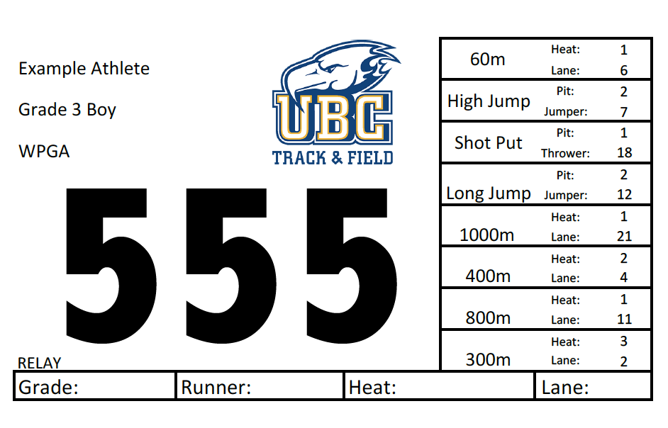

**Parking:**

1. There is free parking on 16th Ave on the way into Campus from Blanca St. (good option for buses) but it’s an 800m walk to the track.
2. There is metered parking on the south side of Wesbrook Mall between 16th Ave and Thunderbird Blvd.
3. There is pay parking in the Thunderbird Parkade on Thunderbird Blvd. just off of Wesbrook Mall.
4. We will be paying officials’ parking so officials please keep your receipts and get reimbursement from the registration desk.

